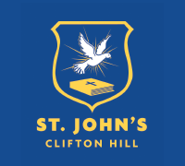
NEWSLETTER

28 April, 2022
St John’s Primary School is committed to the safety, wellbeing and protection of all children in our care.
St John’s Primary School. A small, caring, inner city primary school in Clifton HIll, with the feel of a country school community.

Enrol HERE for 2023!
St. John’s Primary School Clifton Hill

#stjohnscliftonhill
principal@sjcliftonhill.catholic.edu.au

Working Bee - This Saturday, 30th April @ 9-12noon  office@sjcliftonhill.catholic.edu.au if you can join us!  We will need brooms, shovels, sledgehammers, window cleaners and drills etc! Thank you! | SCHOOL PHOTO DAY  FRIDAY (TOMORROW)  FULL summer uniform!  Don’t forget to clean your teeth!

Dear Families,

It has been a joyous and calm return to the school year! Everyone looks happy, rested and ready to grab hold of their learning with both hands! It has been beautiful to be able to see each other's faces without masks and read expressions. Masks have served a powerful purpose and allowed us to be at school; so should you choose to continue wearing one, we will always be supportive of that choice.

Our junior classes always kick off the morning with play! Drop in one morning to see us in action.

Play is foundational to learning as it allows children to use their creativity while developing their imagination, dexterity, and physical, cognitive, and emotional strength. Play is key for healthy brain development and allows children to create and explore a world they can master, conquering their fears while practicing adult roles (rule maker, decision makers, conflict resolvers, negotiators etc), sometimes in conjunction with other children or adults.
Through play new competencies develop; such as enhanced confidence and stronger resilience that supports them in navigating future challenges.

Our Preps, Year 1s & 2s are busily making instruments (their choice with the materials provided) and naturally we now have our own band. They are also learning the art of sewing to develop their fine motor skills, and working together to create a collaborative banner to hang in the library.

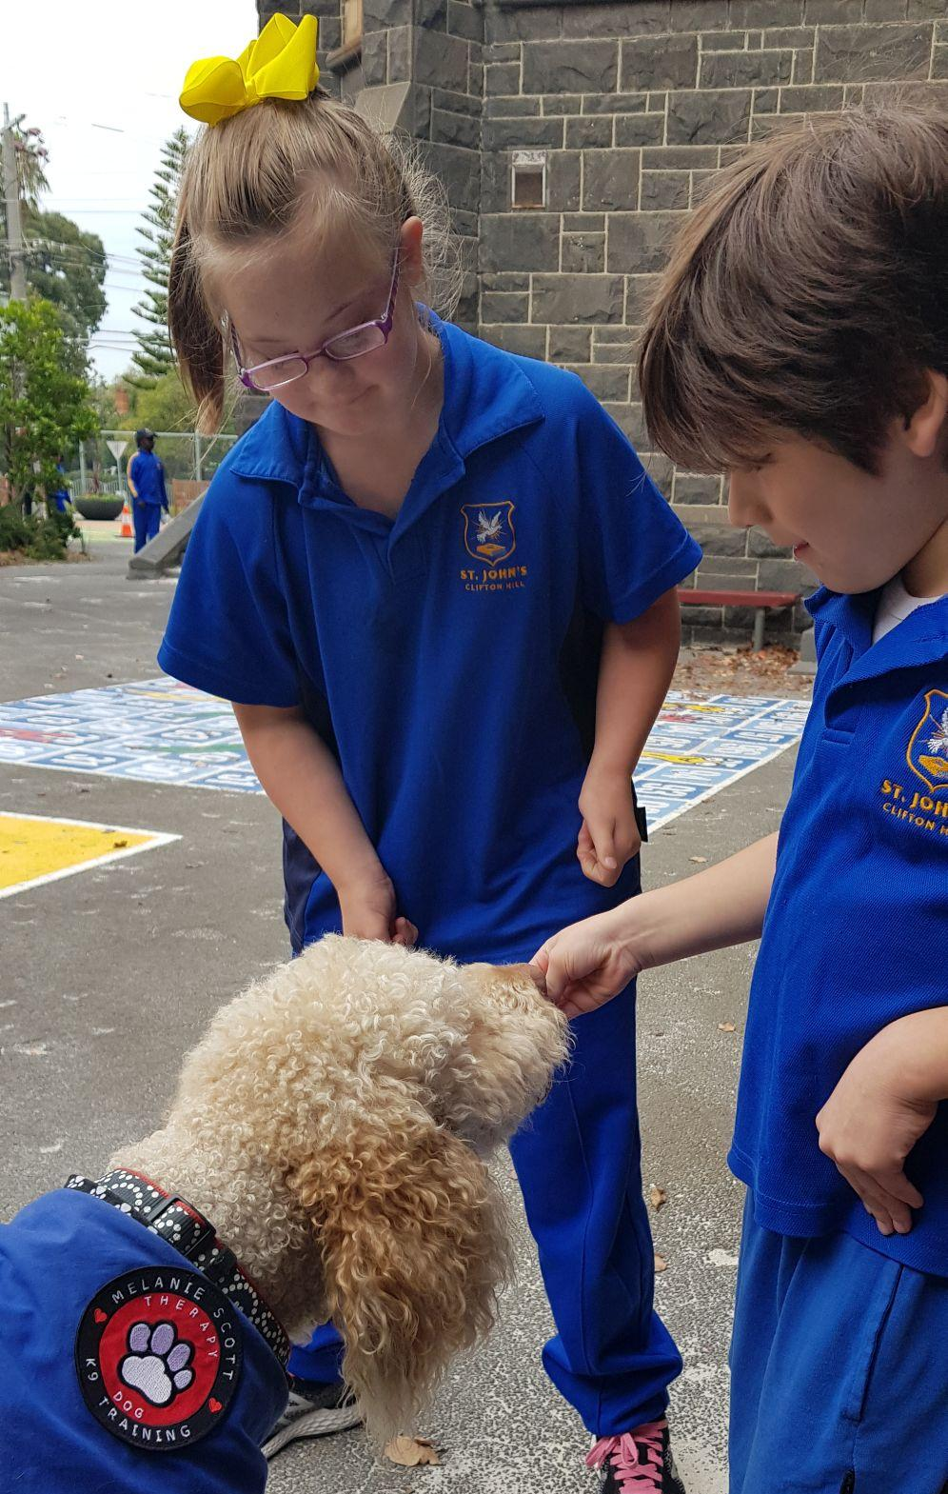
In the yard our kids are hard at playing in the autumn leaves! So we have a bit of a mess with our leaves currently. You’re never too old to play in the crunchy, colourful autumn leaves! This great photo also represents the beauty of mixed age play areas where all students can play with each other!

Many of our students bounce into school on Wednesdays because they remember that Archie, our wonderful learning helper, comes to school on Wednesdays!

Mothers’ Day Breakfast & Mass

We invite all mums, aunties, grandmas, sisters and special women in our students' lives to a special Mothers’ Day breakfast on Friday 6th May from 7.30am in the Aikenhead Hall.

This will be followed by a special Mothers’ Day Mass at 9.45am, if you are able to join us.

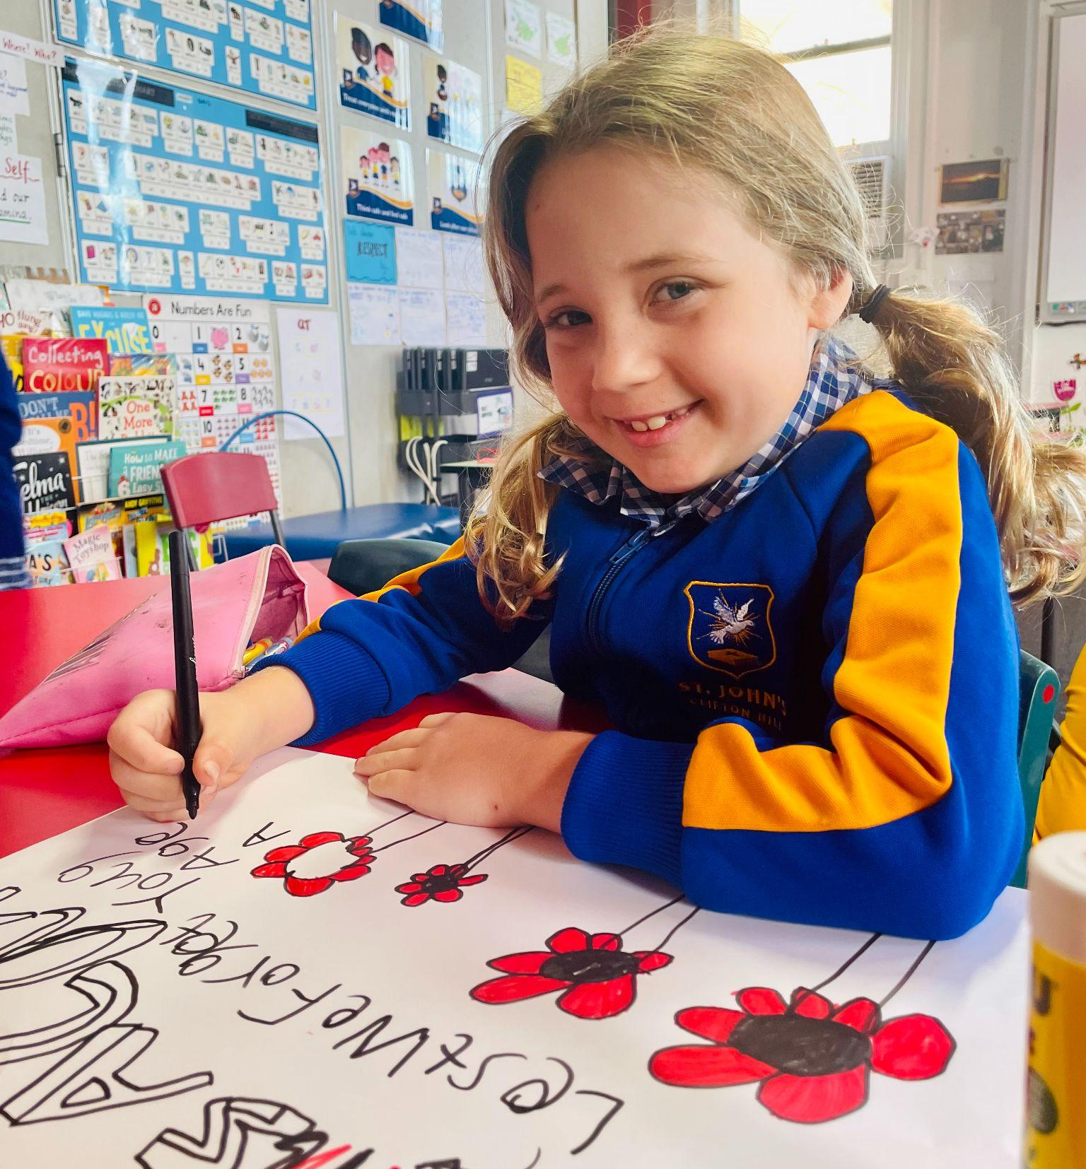
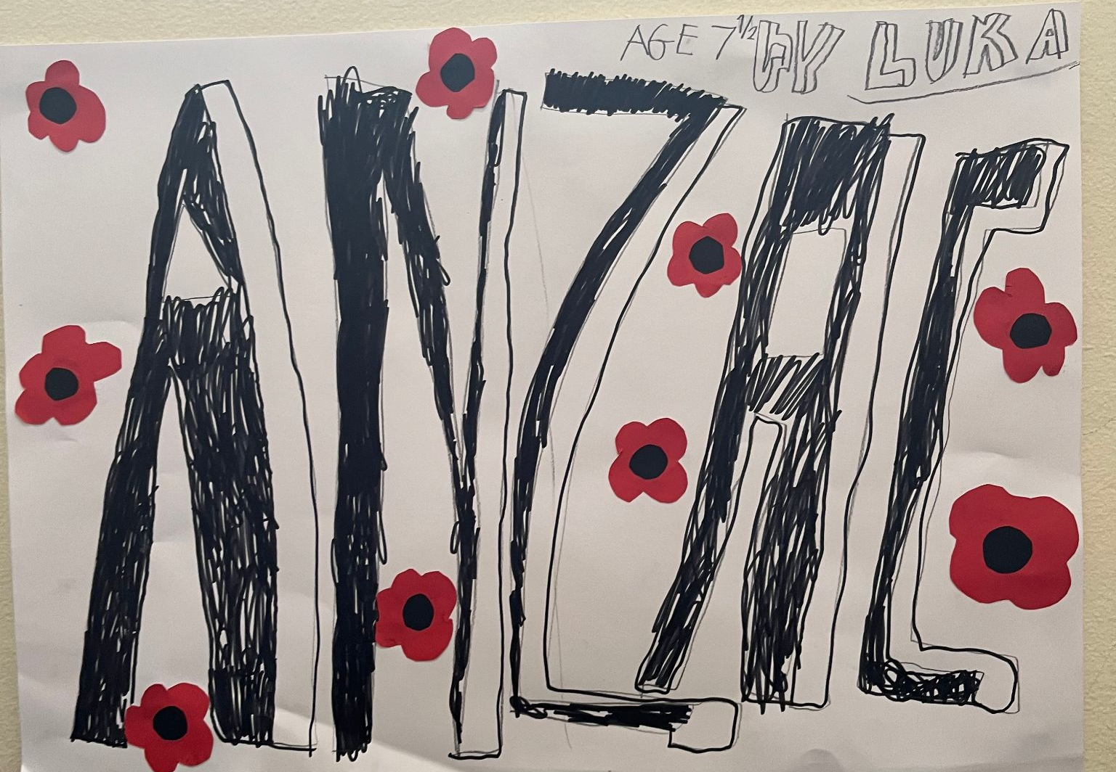

day

This Monday the 25th of April was Anzac day, a national day of remembrance that marked the anniversary of the first landing of the ANZACS in Gallipoli during World War 1.

This day is important to Australians as we commemorate all Australians and New Zealanders who served and died in wars, conflicts, and peacekeeping operations. Lest we forget their sacrifice, and we pray for world peace.
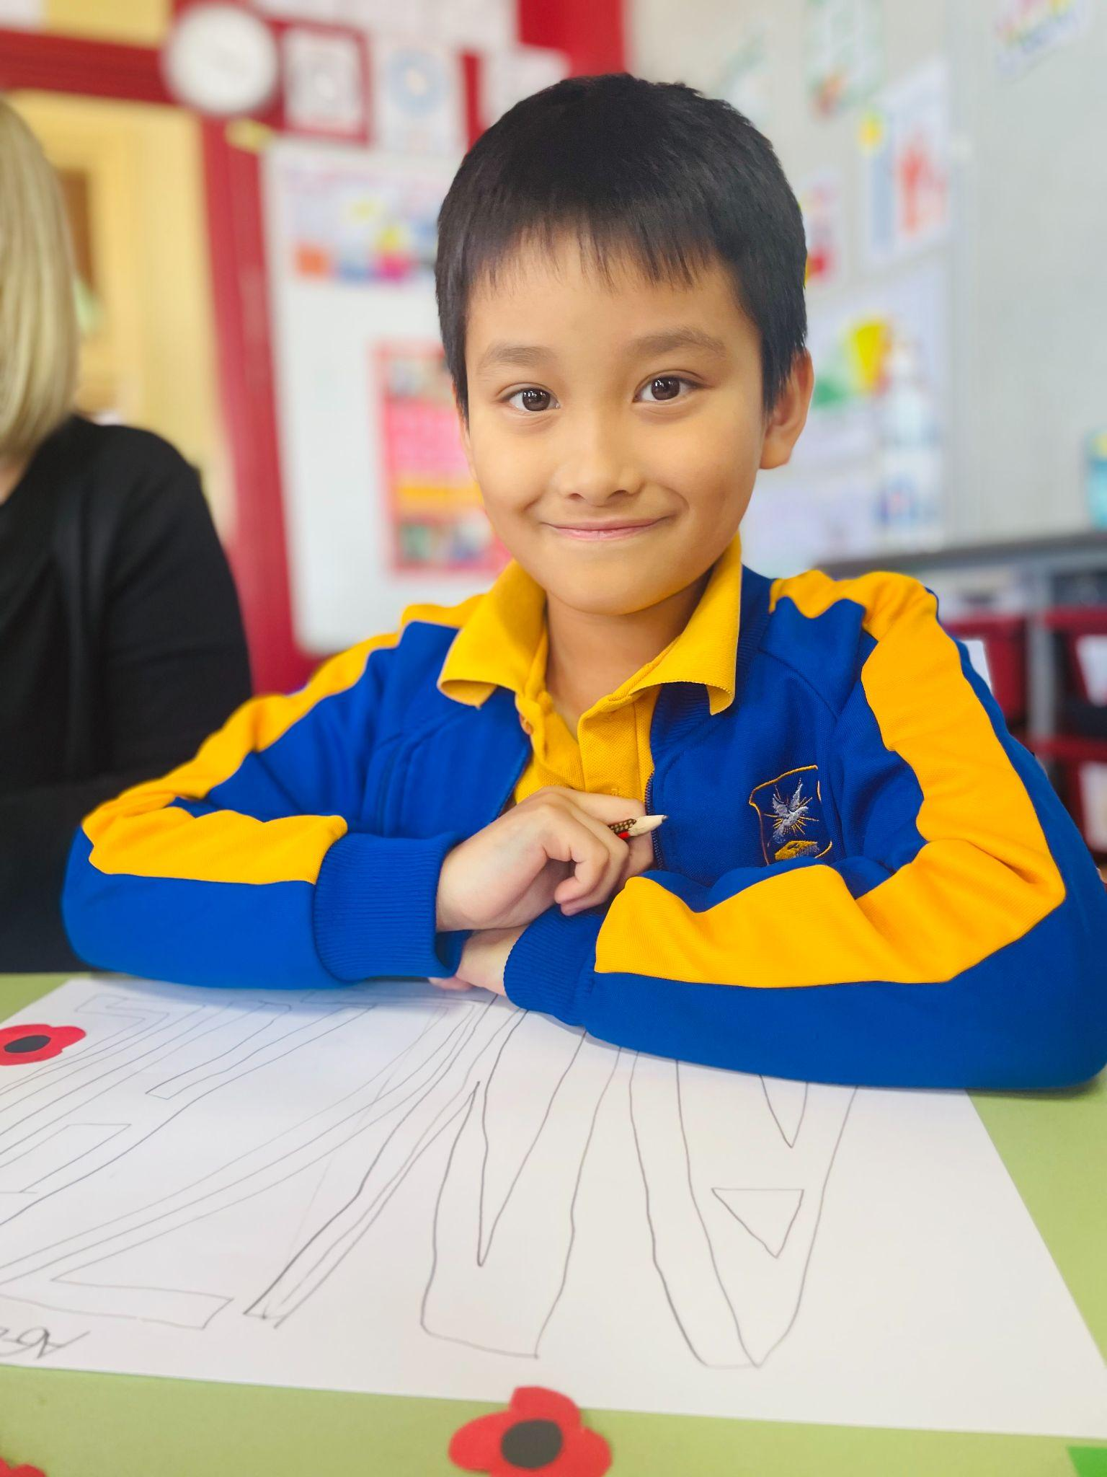

We will have our ANZAC Memorial at assembly this week on Friday @ 2.45pm in the hall. Everyone is welcome!

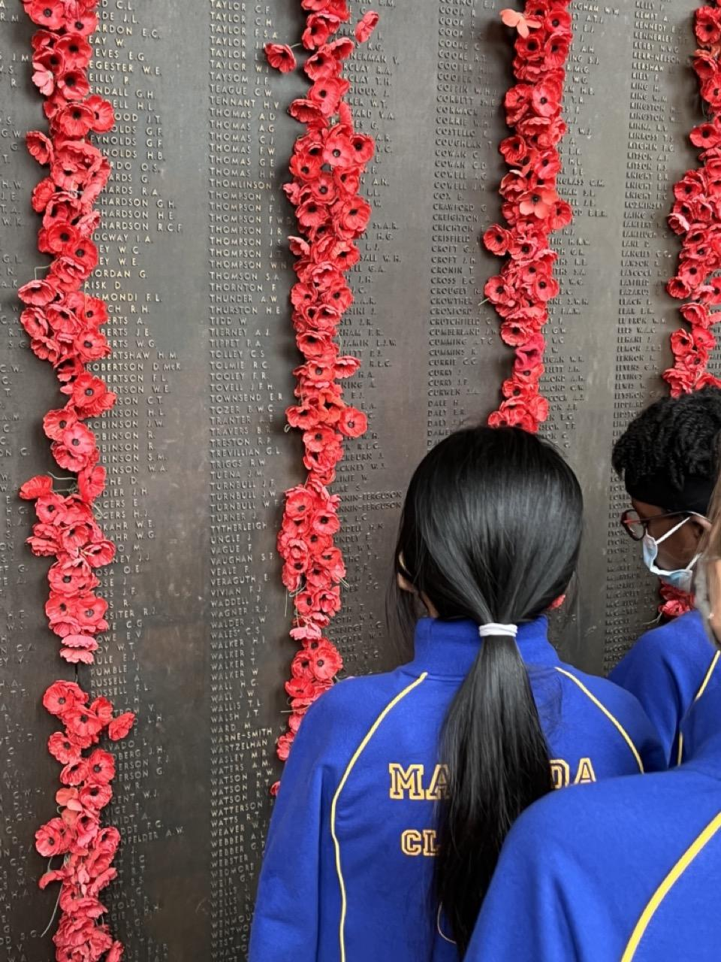
A Canberra reflection…

Year 5/6 students learned about the significance of ANZAC day during their tour of the Australian War Memorial at last term's Canberra camp. Together we laid poppies against names on the many walls that forever remember those who have fought and lost their lives for our wonderful country. They saw the tomb of the unnamed soldier and heard about the landing of our troops at Gallipoli.

Students at St John’s commemorated this day by making art which is displayed around the school. Students made illustrations of the red poppy, a strong symbol used to pay respect and remember those who have served and are serving in war (as they grew in Europe during WW1).

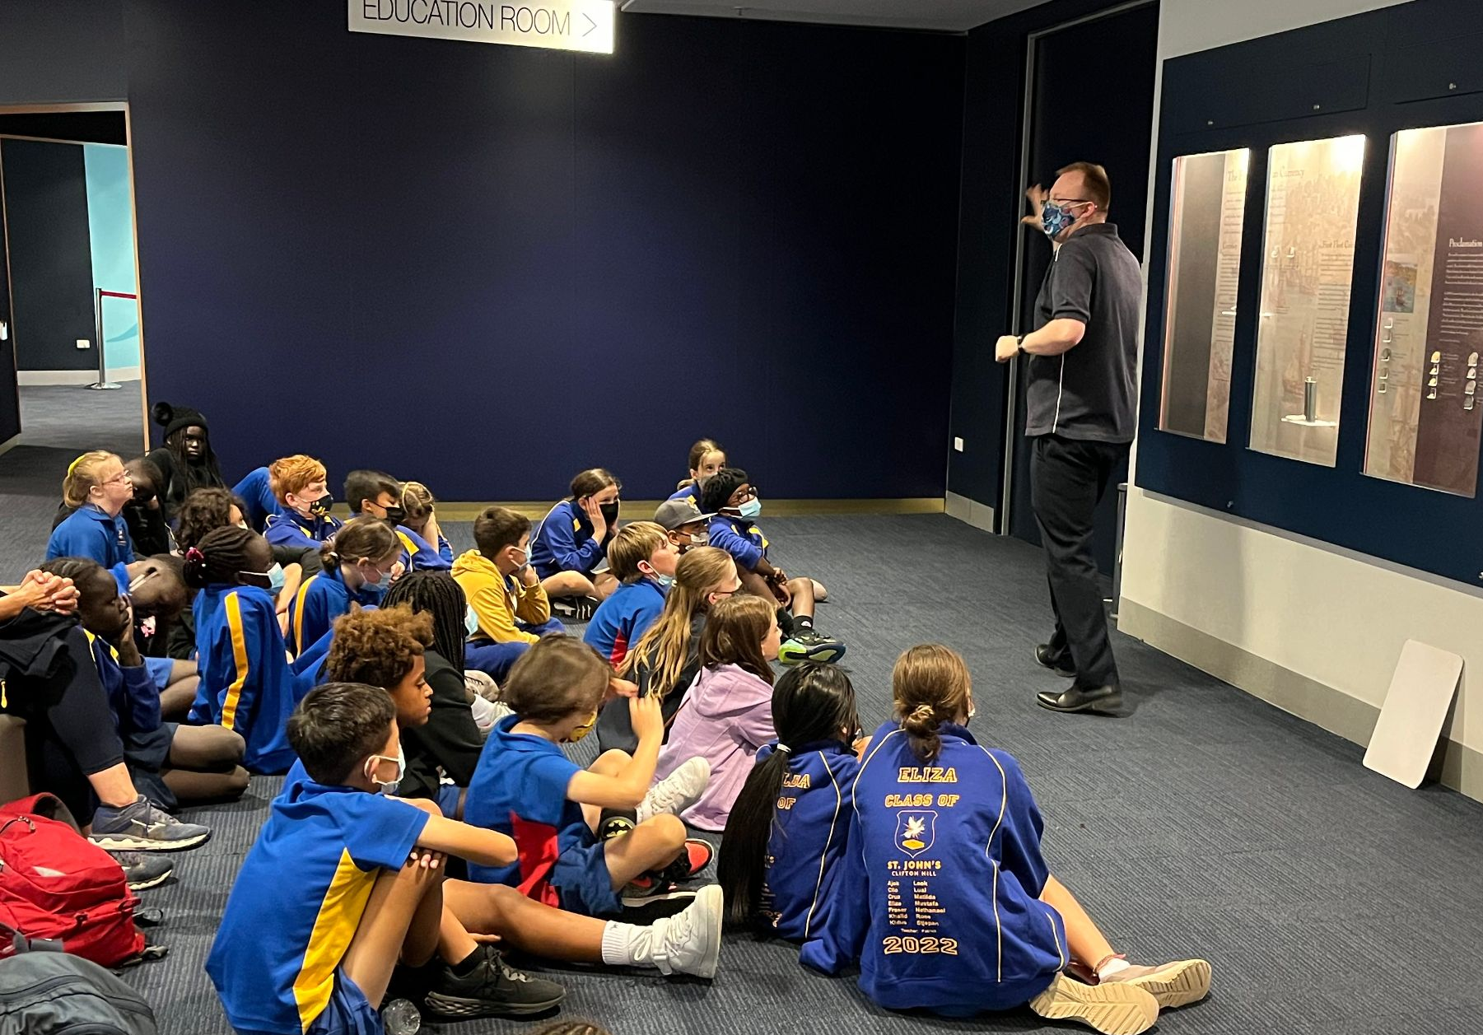
At this camp, students were given the opportunity to participate in a variety of educational programs with a focus on Australia’s history, culture, heritage and democracy.
The Australian Government recognises the importance of all young Australians being able to visit the national capital as part of their Civics and Citizenship education. To assist families in meeting the cost of the excursion the Australian Government is contributing funding of $45 per student under the Parliament and Civics Education Rebate program towards those costs. The rebate is paid directly to the school upon completion of the excursion.

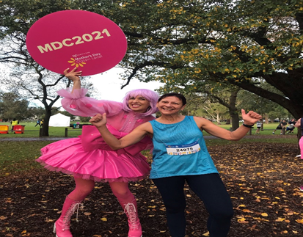
Mothers’ Day Fun Run for Breast Cancer
Hi Everyone!!!
I can’t believe it - it has been an amazing 25 years that I have been running in the Mother’s Day Classic. I remember my first one where I was part of the Events team that organised the event – it was known then as the Sussan Fun Run then.
I am asking you all to support me, if you can, in raising money for Breast Cancer research. I’d love you to make a donation no matter how big or small. If you wish to do so here is the link to her fundraising page.
Thank you. Violet Holcombe.
https://www.mothersdayclassic.com.au/fundraisers/ibolyaholcombe/mothers-day-classic-2022-melbourne

Wishing you all a great week!
Kerrie
Term 2 Dates
Wk 1
Fri 29th Apr School Photo Day - FULL Summer uniform
Prep, Yr 1 & Yr 2 to begin weekly walks to local library
Sat 30th Apr Working Bee (9-12 followed by BBQ & beverage)

Wk 2
Fri 6th May Mothers’ Day Breakfast (7.30am) & Mass (9.45am)

Wk 3
10th- 12th May NAPLAN Year 3 & Year 5
Thurs 12th May OPEN Morning 9.30-11am

Wk 4
Tues 17th May OPEN Evening 5.30-7pm.
Thurs 19th May Staff Professional Learning Day - NO SCHOOL FOR STUDENTS

Wk 5
Mon 23rd May Shared celebration of Feast of St John with St Joseph’s. 10am Mass, followed by tabloid
sports & shared lunch.
Wed 25th May EAC Meeting 7pm - Aikenhead Hall

Wk 6
Tues 31st May OPEN Morning 9.30-11am
Wed 1st June Yr 5 & 6 to The Academy to view their production.

Wk 8
Mon 13th June QUEEN’S BIRTHDAY Public Holiday

Wk 9
Mon 20th June Semester 1 reports sent to parents via email
Thurs 23rd June Final day for students. Parent-Teacher Interviews 4-8pm.
Fri 24th June Parent-Teacher Interviews continue. 9am-12noon.
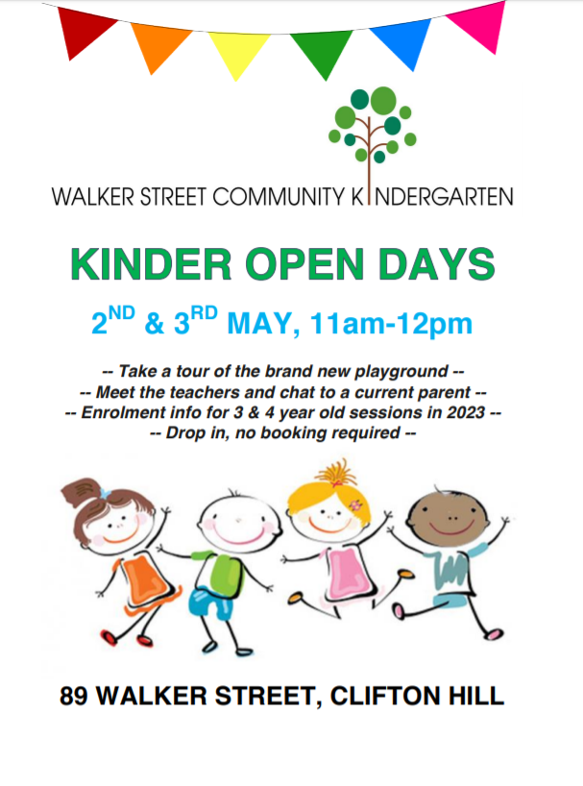

CLOSING SOON! LAST CHANCE
AFTER SCHOOL SOCCER AT ST JOHN’S!
Soccer X is offering 1 hour weekly soccer sessions at St John’s!
The cost is $115 per term and the minimum number of participants is 8.

We are seeking feedback:
Would you be interested in this programme?
Morning or afternoon?

*** Please email the office to let us know at office@sjcliftonhill.catholic.edu.au ***

